PUPIL PREMIUM REVIEW SEPTEMBER 2020
NEWBOLD VERDON PRIMARY SCHOOL’S PUPIL PREMIUM PROFILE AS AT SEPT 2020
Total number of main school and unit pupils: 240
Number of eligible PP pupils as at September 2020:
- 39 main school children – 2 adopted, 2 Looked After Children (LAC), 2 Previously Looked After and 1 Special guardianship order (SGO)
- 0 playgroup child
- 6 unit children
- 1 service parent
There are fluctuations in numbers throughout the year as children move in/out of school or new applications are made. Currently this stands at 19.2%, although, funding is taken from January census day numbers.
Amount per pupil:
£1345 per PP child
£2345 per LAC (Virtual schools retain some of this funding)
£310 service children

Total PP Budget
2014-2015 £75,119
2015-2016 £63,620
2016-2017 £70,960
2017-2018 £75,820
2018-2019 £83,160
2019-2020 £75,507
2020-2021 estimate £73,000

Next review due Sept 2021
ATTAINMENT AND PROGRESS
The school uses Target Tracker for assessing the attainment and progress of pupils over time.
1 point = approximately half a term’s expected progress but terms vary in length.
Pupils are aiming for 5+points per year and 4+ for Year 1
Many pupils with Pupil Premium funding are also on the Special Educational Needs register.
Caution is needed, as some data groups have a very small sample size and therefore each pupil may have a disproportionate impact on the results.
A Pupil Premium Schedule is maintained during the year to show how individual pupils have benefitted from the PP money.

Academic Interventions may include:
- One to one support
- Group support within the classroom
- 5 Minute Boxes – literacy and maths daily one to one support
- Code X – reading and writing small group intervention
- Maths scheme intervention sessions & Maths Shed
- Bug Club Reading, Spelling Shed and Nessy spelling
- One to one LSA reading support (Y1 & Y2 extending in 2020 to Y1,2,3,4)
- Tutoring after school
- Booster sessions after school – planned by teachers and led by LSAs
- Teacher led daily small group learning for specific pupils who have SEND needs.
- Weekly Homework Club for Years 3-6
- SAQ – physical training sessions
- Music lessons, drama club
- Resources to support learning at home – Tapestry and Seesaw platforms
Other possible interventions:
- Attendance Management support
- Play Therapy
- After school club 100% fees funded & residential trips 50% funded
- ELSA (social and emotional) support during the school day
Due to Covid 2020 these attainment and progress results are from 2018-2019 as this was a full year of teaching and learning.
Unit pupils are not included in this assessment data.

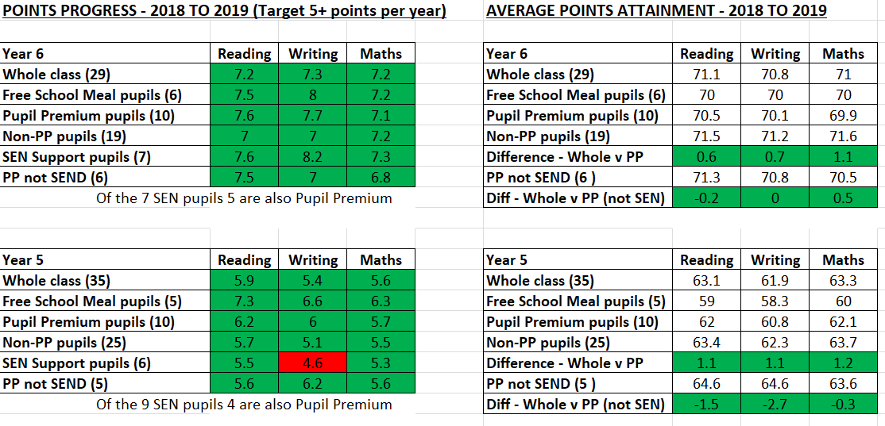

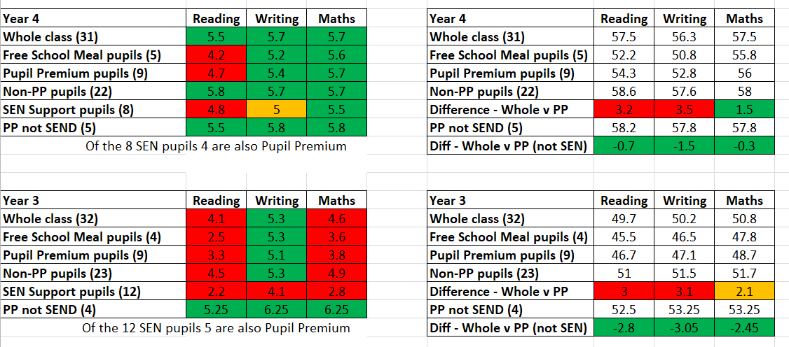

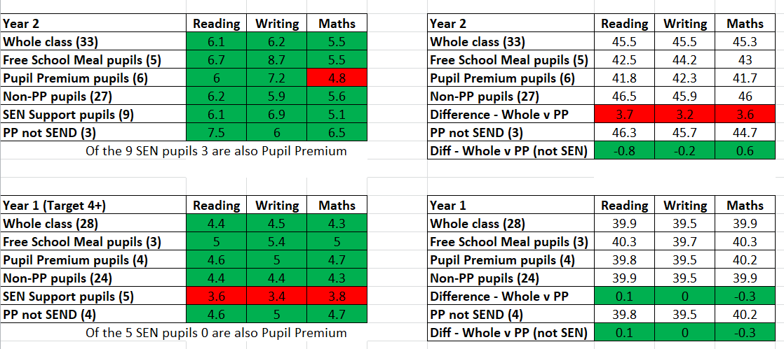

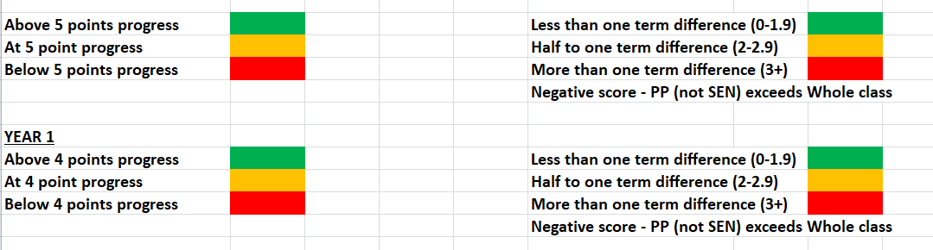

Barriers to future attainment
In school barriers for some pupils:
- Poor starting points in EYFS (90% of children entered Foundation below age expectation in 2019)
- Low level support from home – low level of home reading & support in learning
- Domestic/social issues causing disengagement with learning
- Lack of inspiration for children - low aspirations and few cultural experiences
External barriers for some pupils:
- Low parental engagement with school
- Poor level of parental education
- Some attendance issues – specific family issues
- Online learning issues relating to availability of internet and ICT
- Social and emotional issues within the family
Outcomes to aspire to:
- Academic support to reduce the gap in attainment and progress across the school between PP and non-PP.
- Increased parental engagement & guidance in how to support at home. Learning valued and encouraged by pupils and parents
- Inspirational experiences to excite children into learning
- Decrease in stress/anxiety in children’s lives to enable better engagement in learning. Support for social and emotional needs provided in school.
- Improved attendance
- Greater engagement with online learning

Planned expenditure for 2020-2021:
QUALITY OF TEACHING FOR ALL – IMPROVED PEDAGOGY
Desired outcome | Chosen action/approach | Evidence and rationale for this choice | How will you ensure it is implemented well | Staff lead | Milestones and completed dates | When will it be reviewed and by whom?
Academic support to reduce the gap in attainment and progress across the school. | Support staff in every classroom to support learning in small groups within lessons and in booster sessions. | Smaller groups allows for more focused support and encourages confidence in learners. Allows greater focus on targets. | Class teacher to identify pupils needs and monitor LSA impact. | Class teachers | Termly Target Tracker data reviewed for progress. | Pupil Progress meetings and half termly data. (Progress and attainment)  End of year external examination results. Essex Tracker data analysis throughout the year.
Inspirational experiences to excite children into learning. | Dragon Day activities, visitors into school, visits out (e.g. theatre, Life Education Bus, author visit).  Music lessons offered to all PP pupils from Y3 – Y6 & whole of Unit. Year 4 whole class music lessons and instrument loan.  Subsidised trips and half price residential. Swimming free.  After school clubs paid for to encourage confidence and inspire.  Resources to use at school and for EYFS and nursery pupils to engage in learning at home to engage learners in their passions. | School to fill the gap in offering inspirational experiences to engage the excitement of pupils. Creating a passion for learning. | Professional events and personnel employed to ensure high quality experiences.  Focus on pupils’ needs and passions so personalised focus. (e.g. pupils select instrument to study). | Professionals employed for each experience. Quality overviewed by teachers. Research into suitability and ongoing involvement. | All year groups to consider needs of children. E.g. trips linked to curriculum. Clubs offered to all PP free of charge. | Pupil questionnaire and questioning about learning experiences.  Data re take up of after school clubs and music lessons.  Pupil Premium Schedule is maintained.
 |  |  |  | TOTAL BUDGETED COST: |  | £26,596

TARGETTED SUPPORT
Desired outcome | Chosen action/approach | Evidence and rationale for this choice | How will you ensure it is implemented well | Staff lead | Milestones and completed dates | When will it be reviewed and by whom?
Academic support to reduce the gap in attainment and progress across the school  Focus on specific pupil’s poor attendance | Interventions to be led by LSAs and overseen by teachers. Quality resources purchased e.g. 5 Minute Boxes, Maths intervention scheme and Code X for reading and writing.  Tutoring after school by LSAs. Focused pupils with specific learning goals. Short booster sessions.  Y6 teacher led after school club for booster sessions for SATs  Specialist SEND teacher to provide daily SEND lessons for specific pupils (which includes PP pupils)  Reading LSA to ensure daily reading where pupils are not receiving support at home. Using school phonics scheme.  Attendance Management support for specific issues. | Afternoon sessions ensure QFT isn’t missed. Reinforces recent learning. Encourages confidence. Some may be pre-teaching.  Focus identified by class teacher and reviewed regularly for impact.  Tutoring to help close the gap. Gives support to pupils with less parental support.  Greater focus on SEND pupils’ needs. More personalised curriculum.  Many pupils no reading support at home and therefore this provides the reading opportunities needed.  Improved attendance will promote learning. | Class teacher to identify pupils needs and monitor LSA/teacher’s impact.  Class teacher and SEND teacher working on collaboration to assess progress over time. Moderation undertaken.  Reading LSA to be managed by class teacher.  Attendance Management consultant engaged. | Class teachers, HLTA, LSA  Class teacher and SEND teacher. SENDCO review.  Reading LSA supported by teacher.  Attendance Manager | Termly data review | Pupil Progress meetings and half termly data. Progress and attainment.  End of year external examination results. Essex Tracker data analysis.  Govs overview of attainment and progress termly.  Pupil Progress meetings and half termly data. Progress and attainment.  Reading progress measured by teacher.  Attendance - half termly review HT and clerk. Govs advised termly.
Decrease in stress/anxiety in children’s lives to enable better engagement in learning. Support and nurturing. | Social groups – ELSA staff trained to lead groups and rotated through age range of school.  Play Therapy for identified pupils (rotate this resource during year depending on need)  One to one support either in class or during unstructured times for children with specific SEN needs.  Recruitment of specialist one to one support for specific PP pupils as required.  Lunch time support for some pupils to reduce time wasted on issues relating to friendships and unstructured play. E.g. sports coach and social group inside as needed.  Whole school adult training in Anxiety and ADHD behaviours and strategies. | Some children have serious issues that need overcoming before they can learn effectively.  Some may need specific support to work through issues with a professional play therapist.  Unstructured play times may be times of anxiety and pressure. Poor behaviour may result.  Happier play times ensure settled learning in class.  Adults more able to support pupils displaying these behaviours. | Professional services are engaged. E.g. Play Therapist.  Staff trained to lead social groups.  One to one ELSA/LSAs with behaviour remit. Reducing anxiety and following professional guidance (PRU, EP or Autism outreach).  Fun activities planned to engage and reduce friction. Adult led. | Trained in-house staff (ELSAs)  Play therapist engaged weekly – two pupils each week. Overseen by SENCO.  ELSA, LSA, LTS and sports coaches  School EP training |  | Social groups well attended and feedback pupil questionnaires completed regarding successes.  Therapy review meetings to evidence improvement in social & emotional scores.  Fewer behaviour incidents reported for pupils with known underlying issues.  Action plans followed and incidents recorded to feed into professional meetings and assessments.  CPOM incidents and behaviour monitored over time for focus children.  Staff more able to deal with challenging situations.
 |  |  |  | TOTAL BUDGETED COST: |  | £44,103

OTHER APPROACHES (WHOLE SCHOOL STRATEGIES)
Desired outcome & success criteria | Chosen action/approach | Evidence and rationale for this choice | How will you ensure it is implemented well | Staff lead | Milestones and completed dates | When will it be reviewed and by whom?
Increased parental engagement & guidance in how to support at home.  Learning valued and encouraged by pupils and parents | Cohort meetings/newsletters provided by all staff to engage parents in learning. (Meetings not possible currently due to CV19). Website offering guidance on current topics.  Parents invited in to get involved in school life whenever possible. To be included in inspirational events whenever possible. (e.g. Performances, assemblies, one off events). Parents to be encouraged to comment on online learning platforms.  Parents to be approach with specific suggestions for supporting their child. (e.g. Phonics packs, reading advice) | Workshops were poorly attended in the past but parents happy to attend cohort meetings and receive class newsletters.  One off events opened up to parents whenever possible.  Teachers to review areas where parents can offer more support and consider method of helping parents to get involved. E.g. providing resource. | Staff to plan ways to improve engagement. Use parental feedback.  Teachers’ commitment to engaging with parents.  Teachers to plan for opportunities. | HT, teachers and LSAs  Teachers  Teachers and LSAs |  | Attendance levels measured.  Review of number of events parents involved in.
 |  |  |  | TOTAL BUDGETED COST: |  | £2554

REVIEW OF EXPENDITURE 2019-2020
QUALITY OF TEACHING FOR ALL – IMPROVED PEDAGOGY
Desired outcome | Chosen action/approach | Estimated impact  (Attainment, progress, case studies) | Lessons learnt | Cost £28,734
Academic support to reduce the gap in attainment and progress across the school. | Support staff in every classroom to support learning in small groups within lessons.  SEND Teacher every morning for specific pupils.  LSA Reader in place for Y1 & 2 pupils not supported at home. | See data above. | Teachers need to oversee the target setting and review and use observations to ensure quality maintained.  Teachers use LSA PM to deliver feedback.  Teachers are to ensure that the sessions are rarely missed. | Teachers, HLTA and LSAs.
Inspirational experiences to excite children into learning. | Dragon Day activities, visitors into school, visits out (e.g. theatre group in & two day author and illustrator whole school event).  Music lessons offered to all from Y3.  Subsidised trips and half price residential (Covid so cancelled). Swimming free.  After school clubs paid for (homework, dance, drama, KS1 Craft Club) to encourage confidence and inspire.  Resources to use at school and home to engage learners in their passions (EYFS, Nursery and LAC pupils).  Lemon Jelly anti-bullying workshops to raise self-esteem and avoid negative peer pressure. | Children take part in wider opportunities and engage in learning across the curriculum. Children are able to socialise without money being a barrier.  Children learn to swim.  Children learn to play an instrument. They are inspired by professional teachers & experts.  Homework is supported and children without ICT at home don’t miss out. | Continue to provide such activities and try to establish an even wider set of after school activities.  Use PE Funding too to inspire athletic activities.

TARGETTED SUPPORT
Desired outcome | Chosen action/approach | Estimated impact  (Attainment, progress, case studies) | Lessons learnt | Cost £44,103
Academic support to reduce the gap in attainment and progress across the school | LSA interventions overseen by teachers.  Tutoring after school by LSAs. Focused pupils with specific learning goals. Short series of booster sessions.  SEND Teacher employed part time and LSA Reader.  Attendance Management support for specific issues. | See above | To continue with these support schemes. Essex Tracker data used to analyse success over time and ensure success of interventions.  Attendance Management improves attendance over time.
Decrease in stress/anxiety in children’s lives to enable better engagement in learning. Support and nurturing. | Social groups – LSA trained to lead groups and rotated through age range of school.  Play Therapy for identified pupils (rotate this resource during year depending on need)  One to one support either in class or during unstructured times for children with specific SEN needs.  Lunchtime social groups to support specific pupils during unstructured times. | School social and emotional environment calmer. Pupil resilience higher. | Two school ELSAs now trained up and in place for new school year. One ELSA timetabled for whole school support. Will be more flexible to respond to needs of pupils.  Experienced LSAs in place and supportive in class.  More LSAs are acting as LTS and know the children well and are able to offer better support at lunch times.  Daily social club at lunch times – successfully reducing behaviour and anxiety issues. ELSA availability during lunch time.

OTHER APPROACHES (WHOLE SCHOOL STRATEGIES)
Desired outcome | Chosen action/approach | Estimated impact  (Attainment, progress, case studies) | Lessons learnt | Cost £3,079
Increased parental engagement & guidance in how to support at home.  Learning valued and encouraged by pupils and parents | Cohort parent meetings provided by all staff to engage parents in learning. Successfully attended.  Parents invited in to get involved in school life whenever possible. To be included in inspirational events whenever possible. All children involved in performances during the year (Up to Covid shut down).  Parents approached with specific suggestions for support their child. (e.g. Phonics packs)  Author visit – parents encouraged to attend after school linked art workshops. | Cohort parent meetings well attended and lots of opportunities to share expectations from both sides.  Parents invited in to school at themed days and sporting activities. Performances well attended. Parents’ evening well attended. | Continue to use this method to share supportive ideas for learning.  Even greater involvement to be encouraged next year.  All teachers are to encourage parental involvement through regular invitations into school. | Teacher time planning event.  Planning needed for these opportunities.

