Autumn term 2020: Mr Codd’s class

September 2020

Dear Parents/Carers,

It has been great to see everyone again after such a long and crazy time. I am looking forward to spending this academic year with my new class and sharing with them many exciting experiences. We understand that the last 6 months have been tricky due to Covid 19 and we will focus on supporting the children socially and emotionally as well as academically. Mrs North and Mrs King will be working as Learning Support Assistants in Year 5 and Mr March will cover the class on Thursday mornings.

For the first 4 full weeks of term, we will revise elements of the Year 4 English and maths curriculum that were missed due to lockdown. In the afternoons we will teach wider curriculum lessons as well as completing short burst maths and English tasks that we will call ‘Rapid Reasoning’ and ‘Express English’. This, as well as small group interventions, should help the children to transition back to a more normal curriculum. We will assess the children at the end of this time and use it as a starting point for the rest of the academic year.

As we begin the new academic year, here are a few reminders of how you can support your child during their time at Newbold Verdon Primary School:

We are going to be keeping windows and doors open throughout the day to allow for airflow around the classroom. With this in mind, children are allowed to ‘layer up’ so long as they have the school sweatshirt or cardigan over the top. There is also the option of wearing a school fleece over the top of this.

Please make sure that your child has the correct PE kit in school on the appropriate days. We are trying to teach PE outside as much as possible. Kit should comprise of a white t-shirt, black shorts, jogging bottoms, sweatshirt and trainers. We will not be providing children with spare kit due to the risk of Covid. Earrings should be removed for PE. If their ears have been recently pierced, your child should bring micro-pore tape to cover them for the initial 6 weeks.

School uniform should be worn at all other times. This includes black or grey trousers/skirt/shorts and a white or blue polo shirt. In addition a royal blue sweatshirt or cardigan should be worn and shoes should be black. No jewellery other than watches and ear studs should be worn.

We ask children to take their water bottles home every night and bring them the next morning. This will stop children needing to fill them up during school time and will ensure bottles are regularly cleaned. This year, they will be allowed to keep their bottles on their tables.

Support with your child’s homework is greatly appreciated. Homework will be set every Friday and this will consist of one grammar and one maths piece of work, which will be set on Seesaw (the online platform used during lockdown). Please let us know if you require paper copies instead. The homework should be completed by the following Friday to receive an extra Dragon Wing. Children should not spend more than 20 minutes on each of these, unless of course they wish to do more. The children will also be encouraged to continue to practice their times tables – on TTRockstars. Homework Club will continue to run after school (letters to be handed out shortly).
Reading diaries will be checked every Friday so please can you make sure that you or your child sign for every date that they read. It is expected that children will read 3/5 times per week – even if it is only for 5 minutes. This can be done independently. Children who read 5 times or more in a week will receive an extra Dragon Wing!
This term our main theme is history based; covering World War 2. We will also begin the year with a week’s focus on geography; comparing the Arctic and Antarctic. Children will be bringing home a knowledge mat for the history and science topics. There will be a short quiz at the end of the topics which will be based on these mats. Please encourage your child to try to learn as many of these key facts as possible.
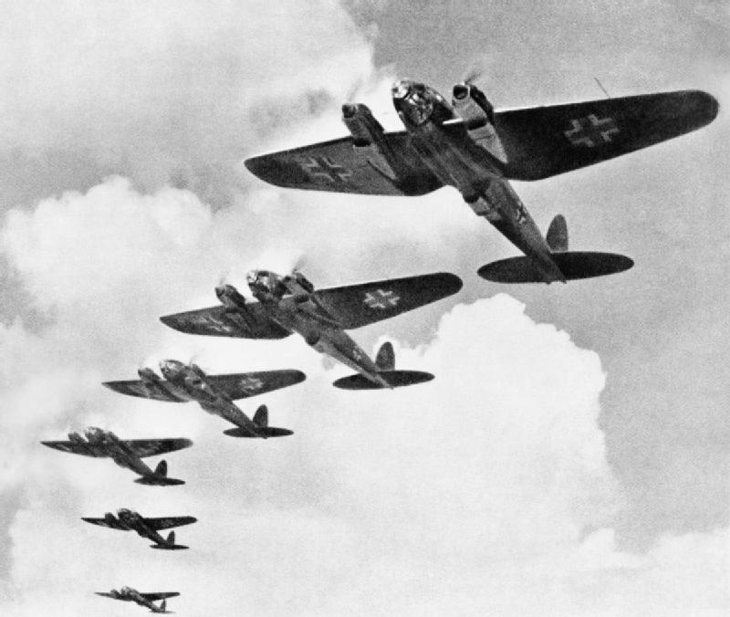
English (guided reading and writing):
Revising and consolidating the Year 4 English Curriculum
Goodnight Mister Tom
Observational poetry

Maths:
Place value and number
Numbers in real life
Written and mental methods

History:
How did the Battle of Britain change World War 2?
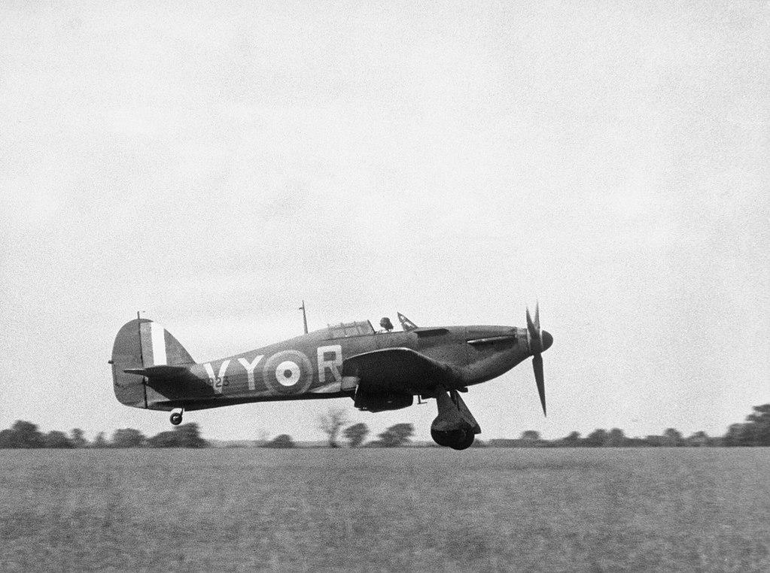
How could Hitler have convinced a nation like Germany to follow him?

PSHE:
Coping with anxiety
Me and my relationships

Computing:
E-safety
Coding

Science:
Properties and changes of materials
Forces

RE:
Why do some people think that God exists?
If God is everywhere, why go to a place of worship?

Art/D&T:
Canaletto - one and two point perspective
Designing, constructing and evaluating Anderson shelters (linked to WW2)

French:
A specialist French teacher will teach 30 minutes of French every week.

Music:
What makes a great song lyric?
What is going in the mix?

PE:
PE is timetabled for Tuesday and Wednesday this term and we will be covering tag rugby, athletics, hockey and outdoor and adventurous activities.

Please arrange to speak to me, via the office, if you have any issues or concerns regarding this year.

Yours sincerely,

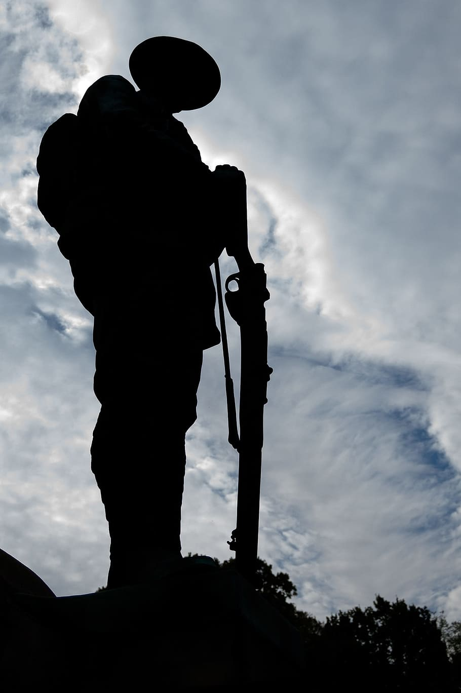
Mr P Codd
Year 5 Class Teacher

