Spring term 2021: Mr Codd’s class
January 2021

Dear Parents/Carers,

I hope everyone was able to have a good end to what was a pretty crazy 2020. This academic year has not been an easy one but I know the children will continue to make the best of difficult circumstances. As we begin the new year, here are a few reminders of how you can support your child:

Please make sure that your child has the correct PE kit in school on the appropriate days. For indoor PE this should comprise of a white t-shirt, black shorts and black pumps. For outside PE lessons and activities they will also need a sweatshirt, some jogging bottoms and a pair of trainers. Earrings should be removed for PE. If their ears are recently pierced, your child should bring micropore tape to cover them for the initial 6 weeks.

We ask children to take their water bottles home every night and bring them in the next morning. This will stop children needing to fill them up during school time and will ensure bottles are regularly cleaned.

This half term, our Year 5 topic has a history theme. We will be looking into the ‘Golden Age’ of the Islamic Civilization, around AD 900, with a focus on the city of Baghdad that was rich in culture and where many great advances took place.

Your support with your child’s homework is greatly appreciated. Homework will continue to be set every Friday and this will consist of spelling, punctuation and grammar worksheets and a piece of maths homework. They will be given a paper copy of this and I will continue to put the homework on Seesaw. The children also have access to TTRockstars to practise their times tables and Bug Club for reading and The Maths Factor.

Reading diaries are checked every Friday so please can you make sure that you/your child sign for every date that they read. It is expected that children will read 3/5 nights per week – even if it is only for 5 minutes. Children who read 5 times or more in a week will receive an extra Dragon Wing!

English:
Robot Girl by Malorie Blackman
Kensuke’s Kingdom by Michael Morpurgo
Poetic style

Maths:
Rising Stars scheme of work

History:
The Islamic Civilization in Baghdad around AD 900.

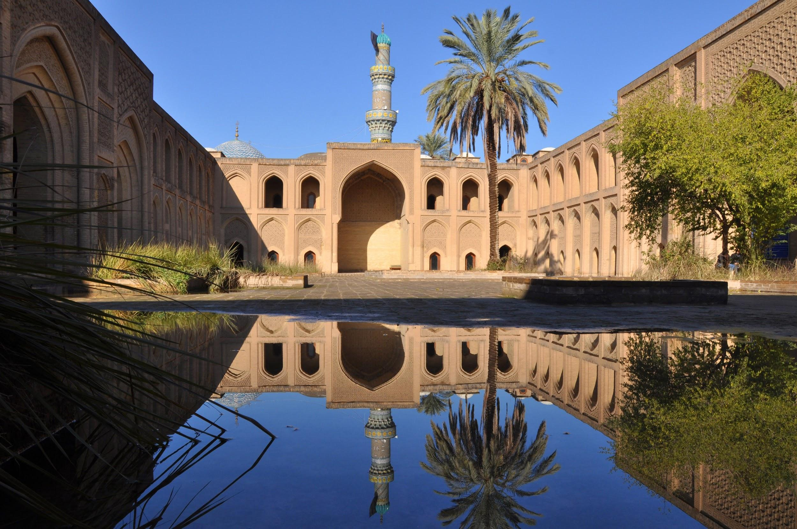
PSHE:
Anti-bullying
Keeping myself safe
Valuing difference

Computing:
Coding
E-Safety

Science:
Space
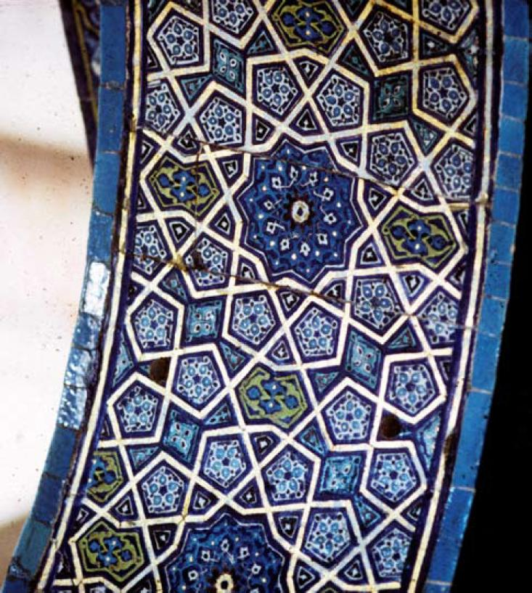
RE:
What does it mean to be a Muslim in Britain today?

French:
Family and friends

Art/D&T:
Islamic art (geometric patterns and block printing)

Music:
Holst’s Planets
Are words enough? (looking at lyrics)

PE:
PE is initially timetabled for Tuesday and Wednesday this term and we will be covering dance, circuit training, tennis and netball. Please make sure your child has the correct indoor and outdoor kit available all week as we sometimes have opportunities to do extra PE sessions.

If you have any queries regarding the content of this letter, please come in and see me.

Yours sincerely,

Mr P Codd
Year 5 Class Teacher

